POINT 2 PROVE
TRAINING
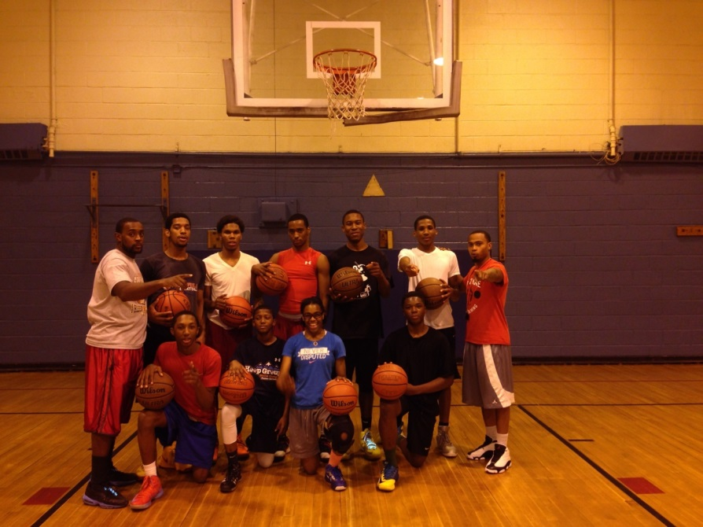
Camps and Clinics

POINT 2 PROVE LLC
228 LELAND AVE
Plainfield NJ, 07062

Introduction
POINT 2 PROVE is a co-owned basketball training service formed in Plainfield, NJ, that specializes in clinics, camps and individual training. POINT 2 PROVE was developed to enhance our student athletes basketball intellect through skills and drills. We enforce the fundamentals, then proceed to a more challenging and rigorous workout which includes: ball handling, passing, shooting, use of screens, agility, conditioning and 1 on 1 moves.
Furthermore, POINT 2 PROVE promotes academic excellence. If requested, we can provide a tutor to help the client excel in the classroom. We are more than a basketball service. We are trying to groom our young men and women to become great individuals. The goal is to continue to build character. POINT 2 PROVE principles are ACADEMICS, BASKETBALL and CHARACTER. The motto chosen was “The STRUGGLE is worth the BENEFIT”. We want the youth to understand that, 100% effort is expected in everything that you do. Nothing in life is given to you. Working for what you want is the best success.

AIM
The ultimate goal is to improve our client’s fitness through basketball. The development of our youth is priority. Implementing numerous skills and drill will give youth the confidence they need to excel in game situations. The staff is highly dedicated to making each individual player better. We want every individual to excel in the classroom and on the court.

POINT 2 PROVE
TRAINING

ANDRE DABNEY
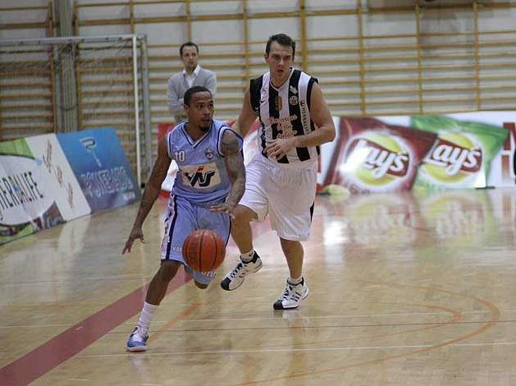

Andre Dabney played professionally overseas. Mr. Dabney played in Argentina and Iceland, where he received multiple accolades and successful seasons. Dabney is currently the freshman head boys’ basketball coach at his Alma mater, Plainfield High School.
During Dabney's tenure at Bloomfield College, he compiled the most impressive list of accolades and achievements of any player in the history of the men's basketball program. Among them are: 4 times both first team All-CACC and first team All-Met, 04/05 CACC Player of the Year, 2 time CACC Tournament MVP, 05/06 All Met Player of the Year, Honorable Mention All-American 04/05, 05/06, & 06/07 seasons, 06/07 Preseason All-American and was chosen to play in the Division-II All-Star game and the John McCarthey Invitational in 2007. Dabney was the first Bloomfield men's basketball player to surpass 2,000 career points. He is currently the school's all-time leader in assists (570) and steals (294). He played in every game that took place during his college career. Dabney was also inducted into the Bloomfield College Hall of Fame. Head Coach Gerald Holmes recruited Andre out of Plainfield, NJ. "Andre is a once in a lifetime kind of player. He's the kind of kid who every coach dreams about having the opportunity to work with. He goes all out, 100-percent of the time.”
POINT 2 PROVE
TRAINING
MIKE GORDON
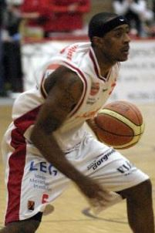
Mike Gordon played professionally overseas. Gordon’s entire professional career was played in Germany, where he received second team all-league honors in his first season. Gordon, a Binghamton University graduate, scored 1,023 career points and left the program's career leader in assists (403) and steals (210). He made 102 consecutive starts and capped his outstanding four-year career with repeat second team America East all-conference honors in 2007-08. As a senior, he led the America East and ranked 25th in the country in steals. Gordon also was selected to the America East all-defensive team three straight seasons. Gordon is now the head varsity assistant at his Alma mater, Plainfield high school. Since Gordon’s arrival, the team has won two Group III, State Championship.
"I've played basketball my whole life and my dream is to give the youth all the knowledge that I have. I want to show the youth that I am a product of hard work, will and determination. Getting together with Andre Dabney to make this dream a reality is a blessing.”

POINT 2 PROVE
TRAINING

TRAINING SESSIONS

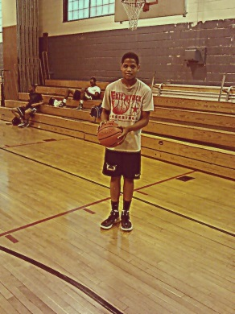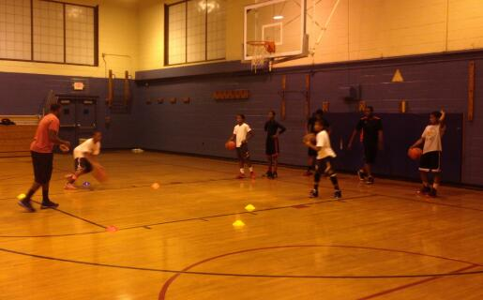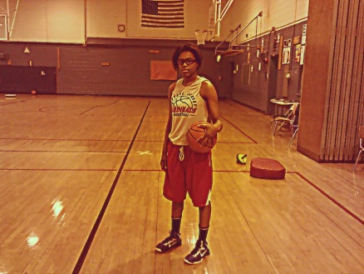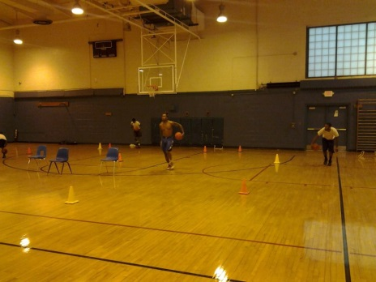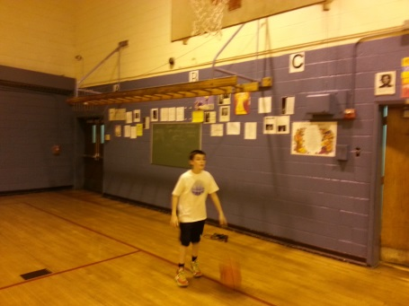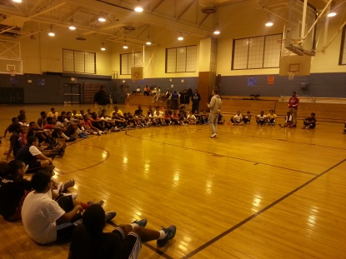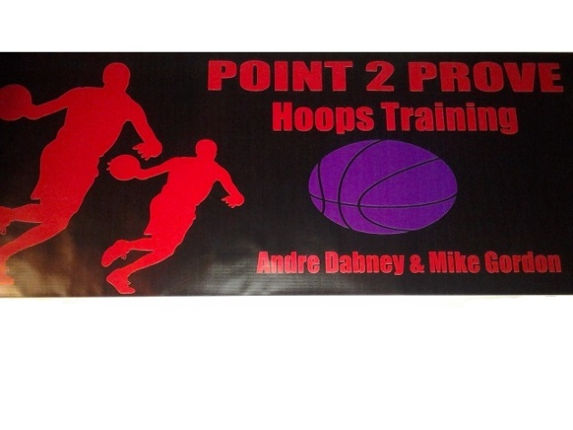
POINT 2 PROVE
TRAINING

QUOTES
“When I was young, I had to learn the fundamentals of basketball. You can have all the physical ability in the world, but you still have to know the fundamentals.” Michael Jordan
“What you are as a person is far more important than what you are as a basketball player.”
John Wooden

“If we can take young people who excel at the highest levels, put them on the same kind of pedestal as the all-state basketball player and begin to get the same kind of recognition, it will have a profound effect, and we are finding that it does.”
Benjamin Carson
“You see, in sports you have so many things that aren’t expected. There's so much uncertainty. So when players find themselves in a situation where management has a great deal of integrity and they can depend on my word or anybody else's word in the organization, they feel secure. And if the players feel secure, they don't want to leave here. And if they don't want to leave here, they're going to do everything they can on the court to stay here.”
Red Auerbach

“The thing I loved the most - and still love the most about teaching - is that you can connect with an individual or a group, and see that individual or group exceed their limits.”
Mike Krzyzewski

POINT 2 PROVE
TRAINING

What we are offering you:

Point 2 Prove offers you one of the following packages to become one of our valued sponsors. Your involvement will aid Point 2 Prove in helping to improve and raise the number of opportunities for our young athletes wishing to become more involved in basketball. It will help us to be able to offer even deeper discounts and free participation to some less fortunate youth in need of quality training and opportunities. We estimate impact on over 250 youth and over 500 parents and guardians of all ethnicities and income levels in the local area through advertisement and participation in camps. Depending on your package Point 2 Prove will have the following rewards for your business and company.

Advertising & Business Promotion;
Hyperlinked logo on front page of our website leading consumers to your website
Link to sponsors section with provision for special offers and promotions
POINT 2 PROVE endorsement of products by staff wearing sponsors clothing and/or footwear.
Inclusion of your logo on media advertisements, camp flyers, posters, and mail outs.
POINT 2 PROVE website will be the main communication link with major basketball teams, coaches and parents across the state generating thousands of hits throughout the summer.

SPONSORSHIP LEVELS:

BRONZE ($150) – Your business logo or contact information will be linked from the
Point2prove.weebly.com sponsor page.

SILVER ($300) – In addition to the benefits of the Bronze Level, your business logo will be displayed on the banner at our sign-in table and on all advertising brochures.

GOLD ($500) – In addition to the benefits of the Silver Level, your business logo or contact information will be linked on the point2prove.weebly.com home page. Your logo will be present on all Point 2 Prove Banners that will be visible during each clinic. You will also receive a “Thank You” plaque suitable for display in your place of business.

Platinum ($750) - In addition to the benefits of the Gold Level, your business name will be on all Camp T-shirts. Your business will get a personal signed ball by Mike Gordon and Andre Dabney. Your business will be listed as a sponsor on all Point 2 Prove marketing material distributed throughout the State of New Jersey.

*If you are able to contribute materials, supplies, etc. for POINT 2 PROVE clinics please contact us and let us know how you can help the youth!

Please fill out the form on the preceding page and include your logo (on a CD in JPEG format, a web link to your graphic or a scanned item) along with your check. Please make the check payable to “Point 2 Prove.” THANK YOU

POINT 2 PROVE
TRAINING

Package Selection:
Platinum ($750) Gold ($500) ________ Silver ($300) ________Bronze ($150) ________

Date: ______ Business/Company Name: ______________________________

Address: ____________________City:_____________ State: _____Zip: _______

Phone: _________________Contact Name: ____________________________

Business website address: __________________________________________

Business e-mail address: ___________________________________________

POINT 2 PROVE
TRAINING

